CS427 - Game Development and Visualization

Group 29 - 1651003 - Nguyễn Thị Minh Anh

**Final Project: 3D Game Report**

**Game name:**

Unity-chan.

**Engine using:**

Unity 2019.1.3f1 Personal - 64 bit.

**Main idea:**

“Unity-chan” is a game based on a cute 3D model girl "Unity-chan!" (Kohaku Ootori) has come from the Japanese game scenes! “Unity-chan” is an original character for developers provided by Unity Technologies Japan. In this game, her mission is trying to get as highest score as possible, by gaining diamonds, and go to the goal area to finish.

**How to start?**

Click “Play” button on main screen to start.

**How to play?**

Using keyboard to move Unity-chan.

**Main techniques:**

- 3D Object and Renderer.  
- Set up 3D environment.  
- Camera component and Third person viewer.  
- Third person controller.  
- 3D physics collider.  
- Animation platform.  
- Rigidbody component.  
- Collision and Trigger event.  
- UI layout: Canvas with Button event, Texts, Panel.  
- UI Menu and Sound.

**Resolution:**

1366 x 768.

**Main Scenes: 4**

* **Introduction scene:** with some animation effects.

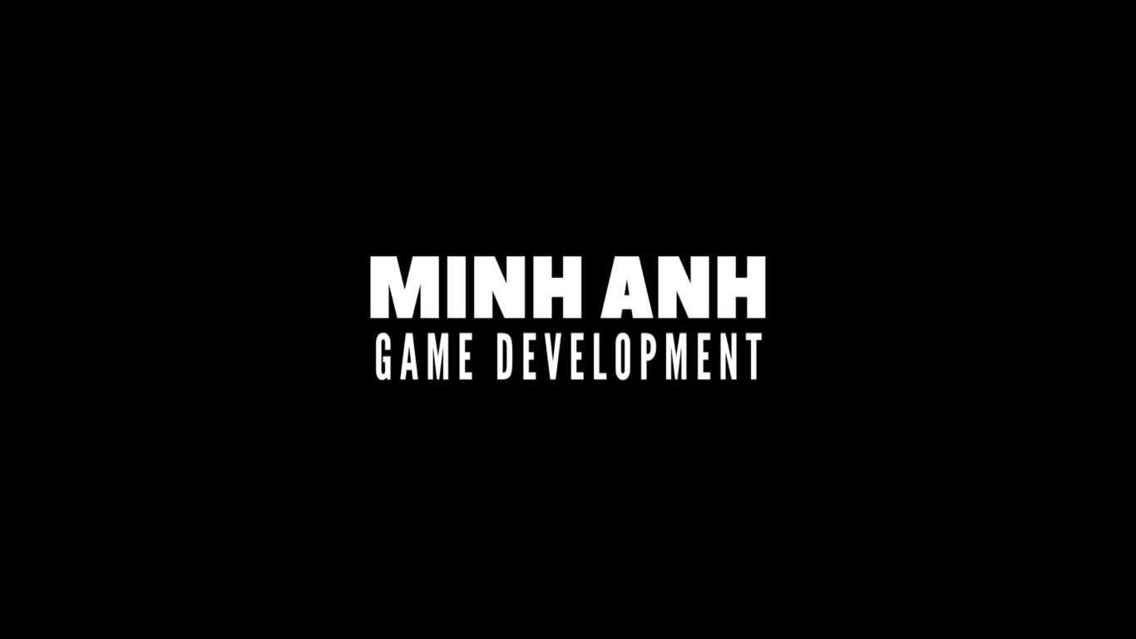

* **Navigation scene:** This scene is also the main menu for the game, press “Play” button to start, press “View credits” to view some credits, and press “Quit” to exit the game. There is also a “Reset” if player wants to reset the best score to 0.

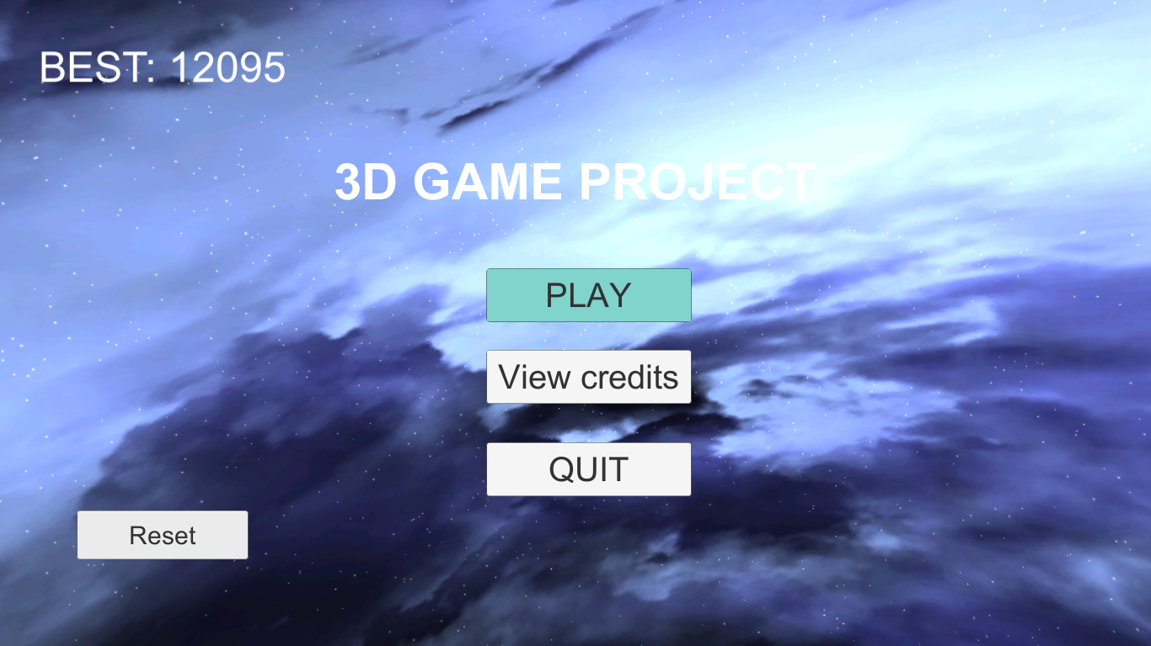

* **Play scene:** (more details in next section).

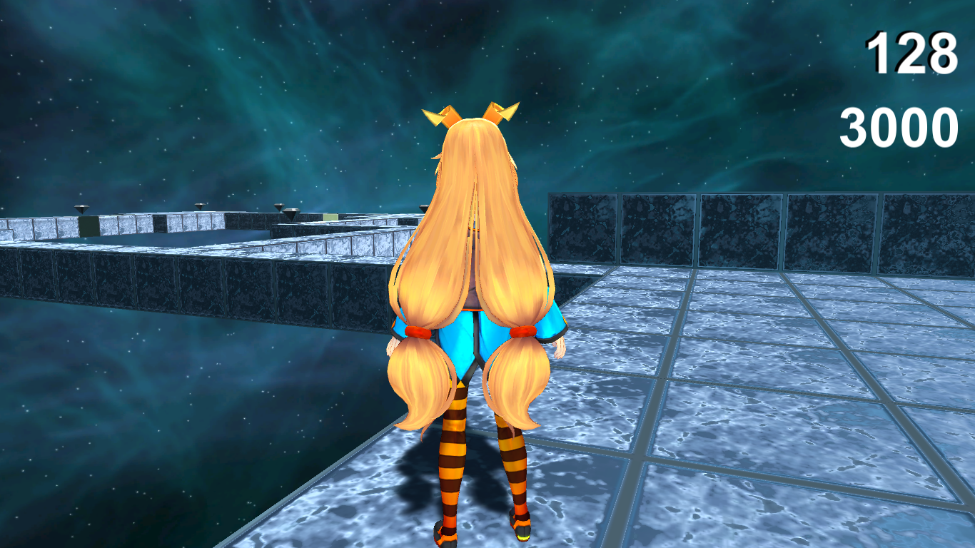

* **Credit scene:**

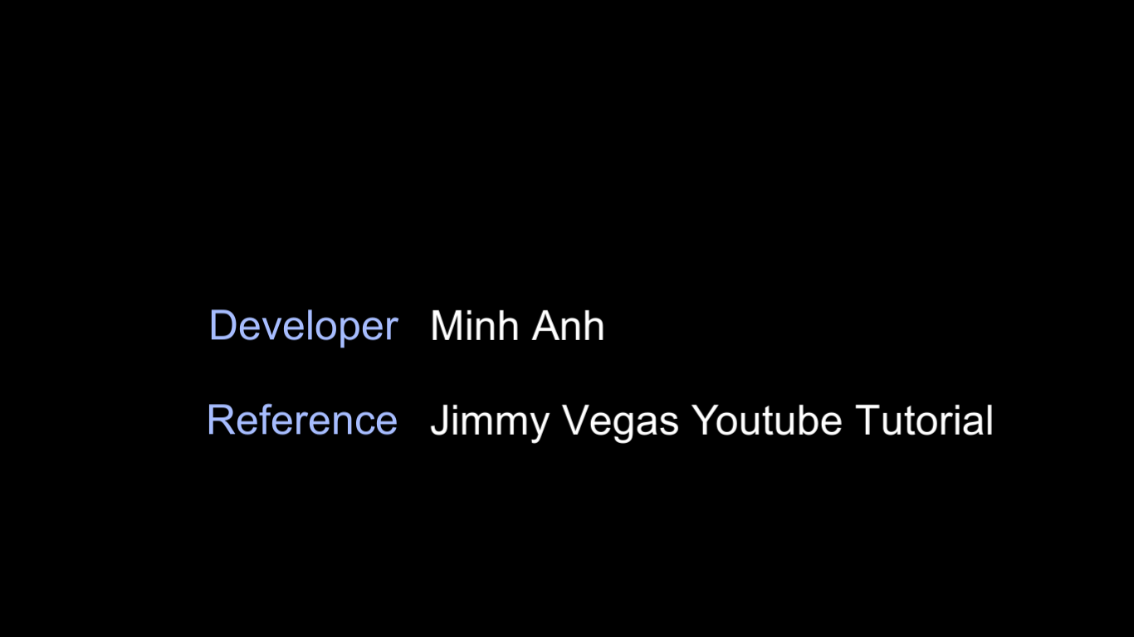

**Details about game:**

* **Target:**

- Try to collect as many as possible all the available diamonds on the screen (1 diamond = 1000), to gain highest score, then go to the goal area to finish.

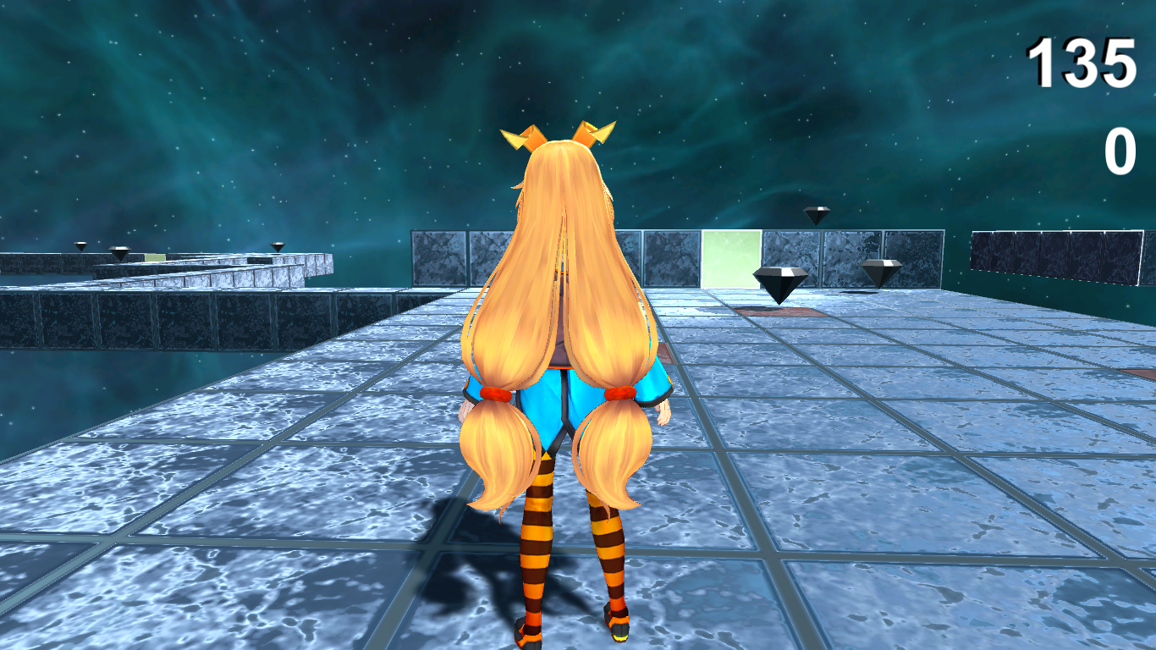

- When Unity-chan has arrived the goal area, Total score will show (Total score = time left + score).

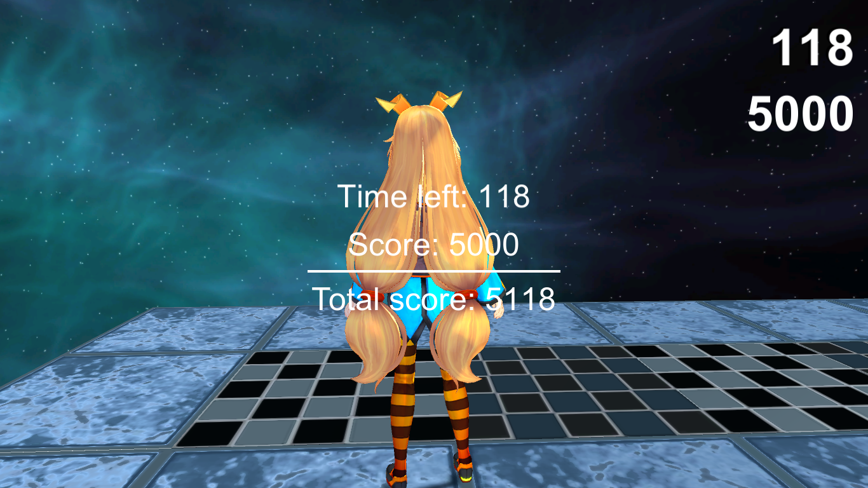

- If Unity-chan falls off 3D platform, “You fell” notification will show, and the game will restart after that.

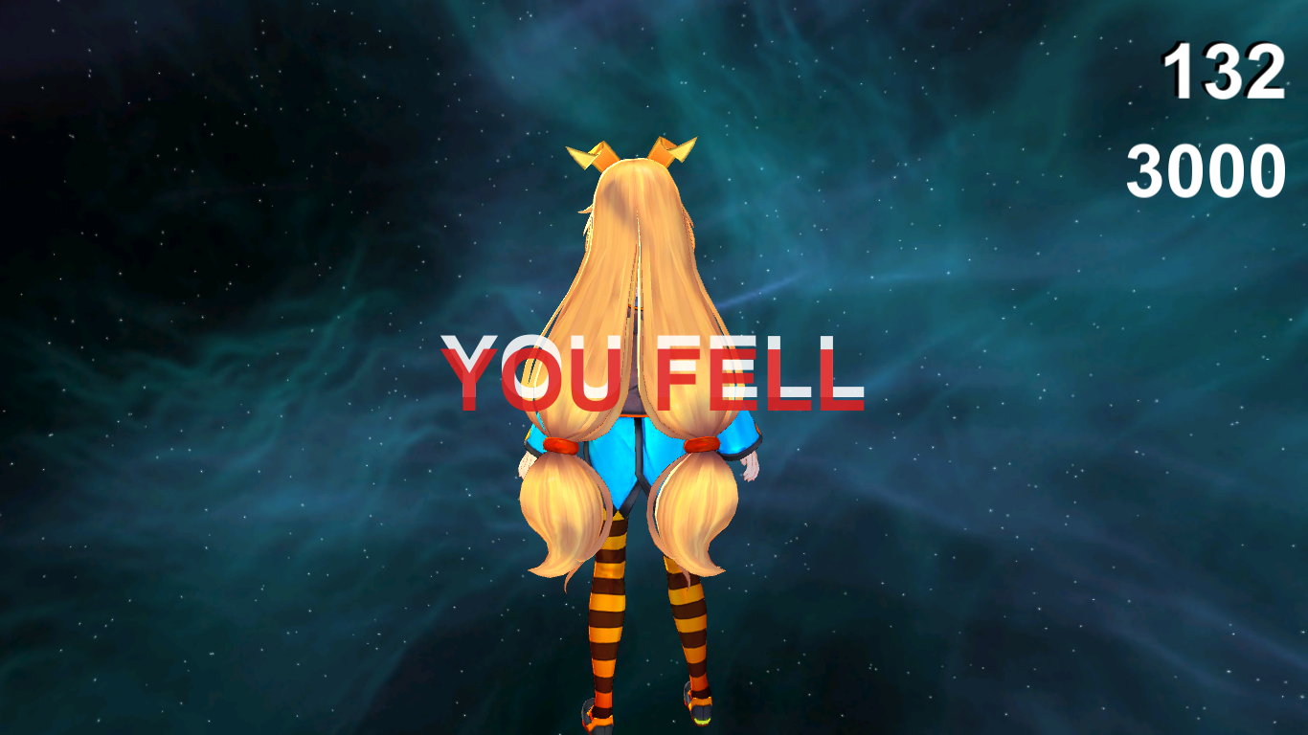

* **How to play:**
  + Using keyboard to move Unity-chan, left-click mouse to face Unity-chan.
  + Left arrow: turn left, right arrow: turn right, Upper arrow: move forward, Lower arrow: move backward, Space: jump.
  + Esc: Pause game.
* **UI:**
* Navigation: (after pressing Esc).

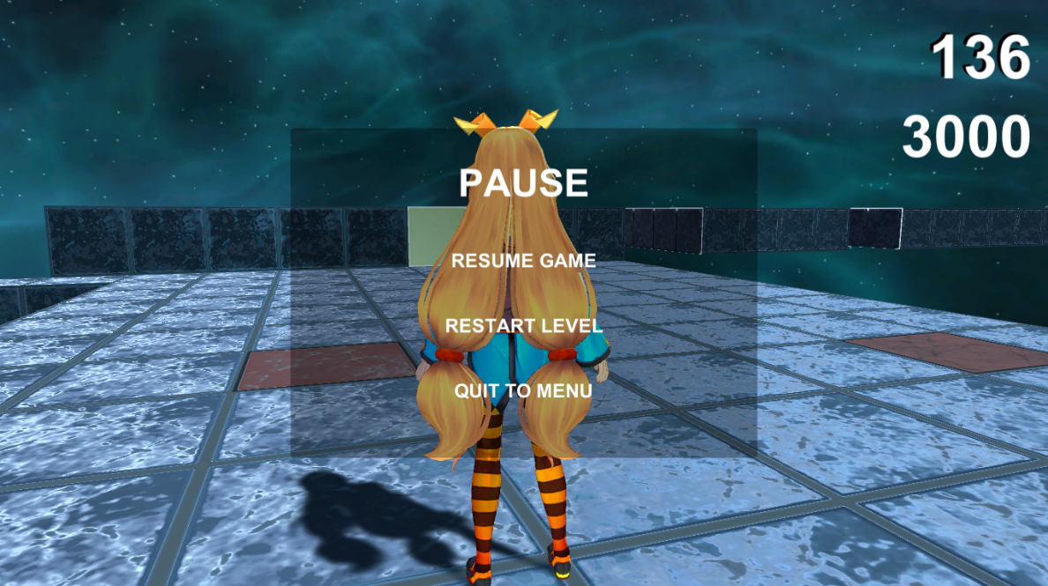

**References:**

Jimmy Vegas Youtube Tutorial: <https://youtu.be/w1Y0JwmazVM>

Choco-series free asset: <https://jvunity.weebly.com/choco-series.html>

Unity-chan asset: <https://www.dropbox.com/sh/owpqvag1mztev3b/AAAgGTkzXzGFA0iHxw6nykswa/ThirdPersonCharacter/Assets/unitychan?dl=0&subfolder_nav_tracking=1>